U S E R M A N U A L

2X2 4K VIDEO WALL CONTROLLER

Enjoy the vivid world!
INTRODUCTION
2X2 4K VIDEO WALL CONTROLLER:
The 4K 2x2 video wall controller , support 1-way HDMI or DVI input and 4 HDMI output, the main function is to divide a complete HDMI,DVI HD image signal into 4 blocks and assign to 4 video display unit (such as Rear projection unit, LCD TV, etc.), Complete with 4 HDMI high-definition video display units to form a large dynamic image screen.
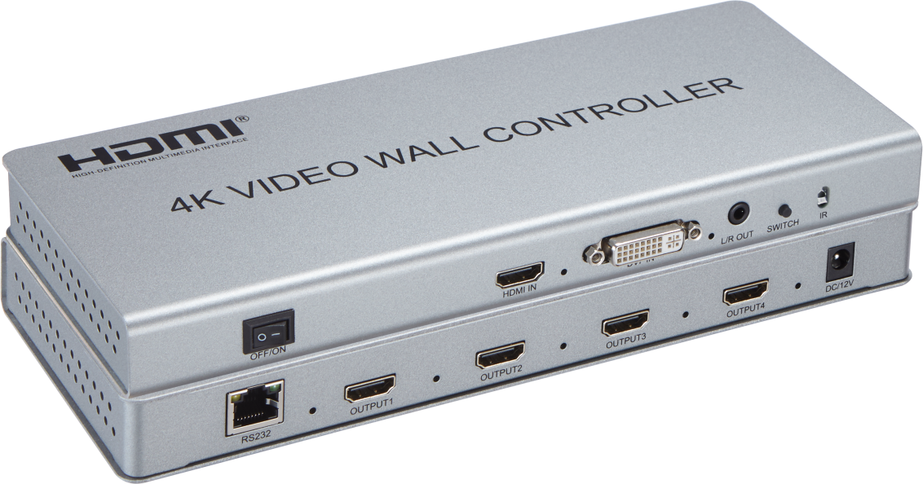
Three splicing modes : 2x2 ; 1x2 ; 1x4。
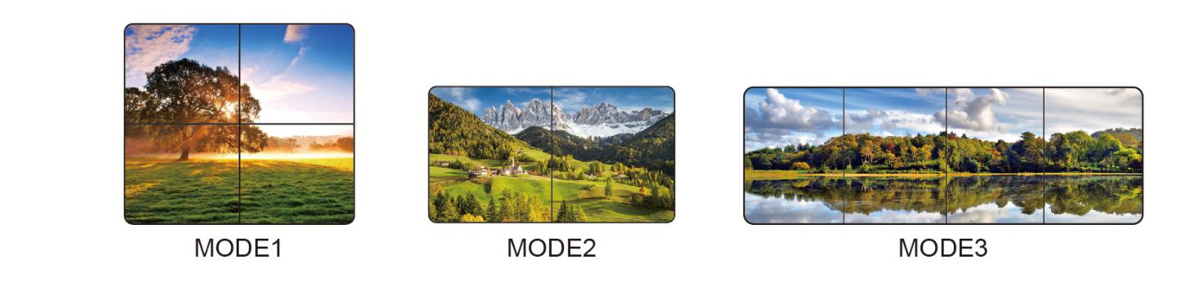
FEATURES
Support 1 DVI or HDMI input
Input support HDMI1.4 ,HDCP1.4
Support 4 HDMI outputs, 1 3.5mm audio output
Input resolution include 1920x1080P 25/30/50/60HZ,3840x2160P 25/30HZ; Output resolution include 1920x1080P 25/30/50/60HZ
Input format: YUV422 16bit、RGB444 24bit; Output format: RGB444 24bit
Support RS232 protocol (Net port RJ45)
Easy to operate, plug and play
DC12V/2A power adapter

Physical interface diagram
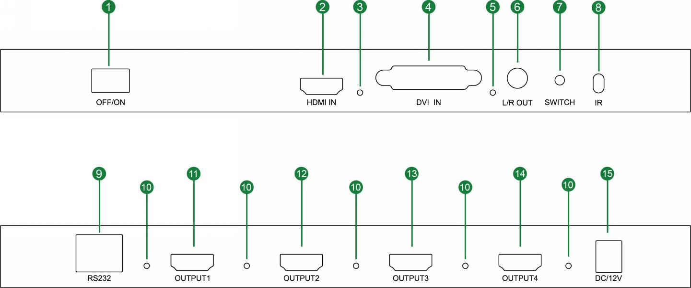
1： OFF/ON --- OFF/ON 2： HDMI IN ---HDMI input
3： HDMI input signal indicator 4： DVI IN --- DVI input
5： DVI input signal indicator 6： L/R OUT -- 3.5mm Stereo output
7： SWITCH --- SWITCH 8：IR --- Infrared receiver
9： RS232 --- RS232 port 10： HDMI output signal indicator
11-14: OUT PUT1-OUT PUT4 port 15： DC/12V ---DC12V Power Interface
Product Picture
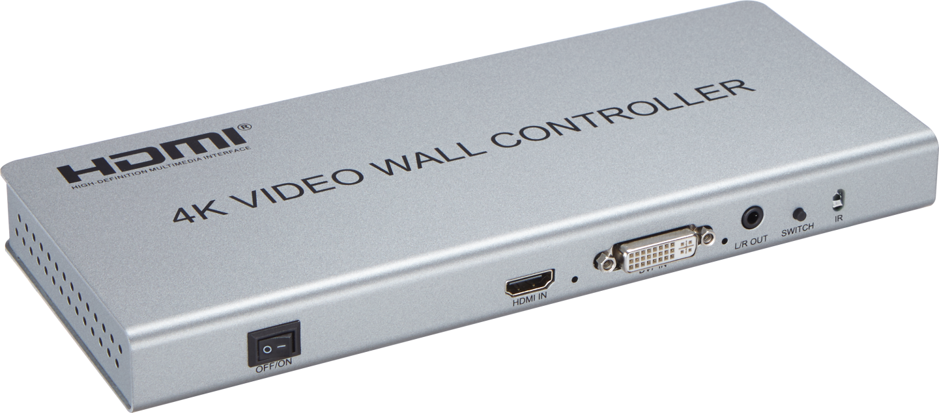

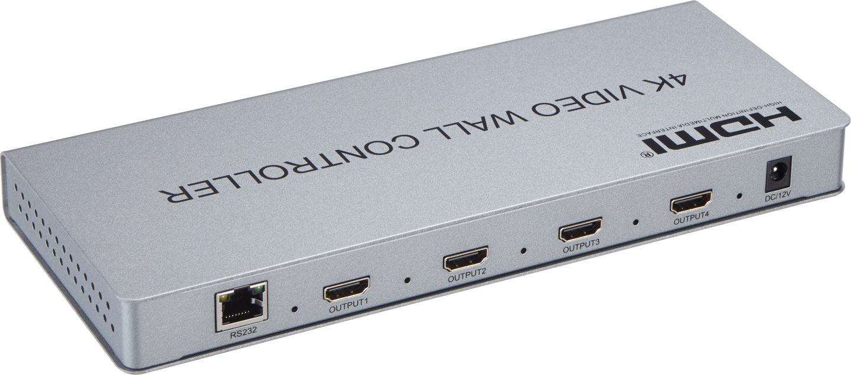

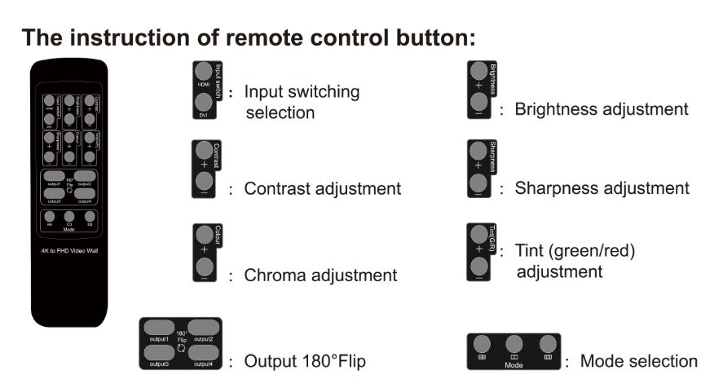

Operating and Connecting
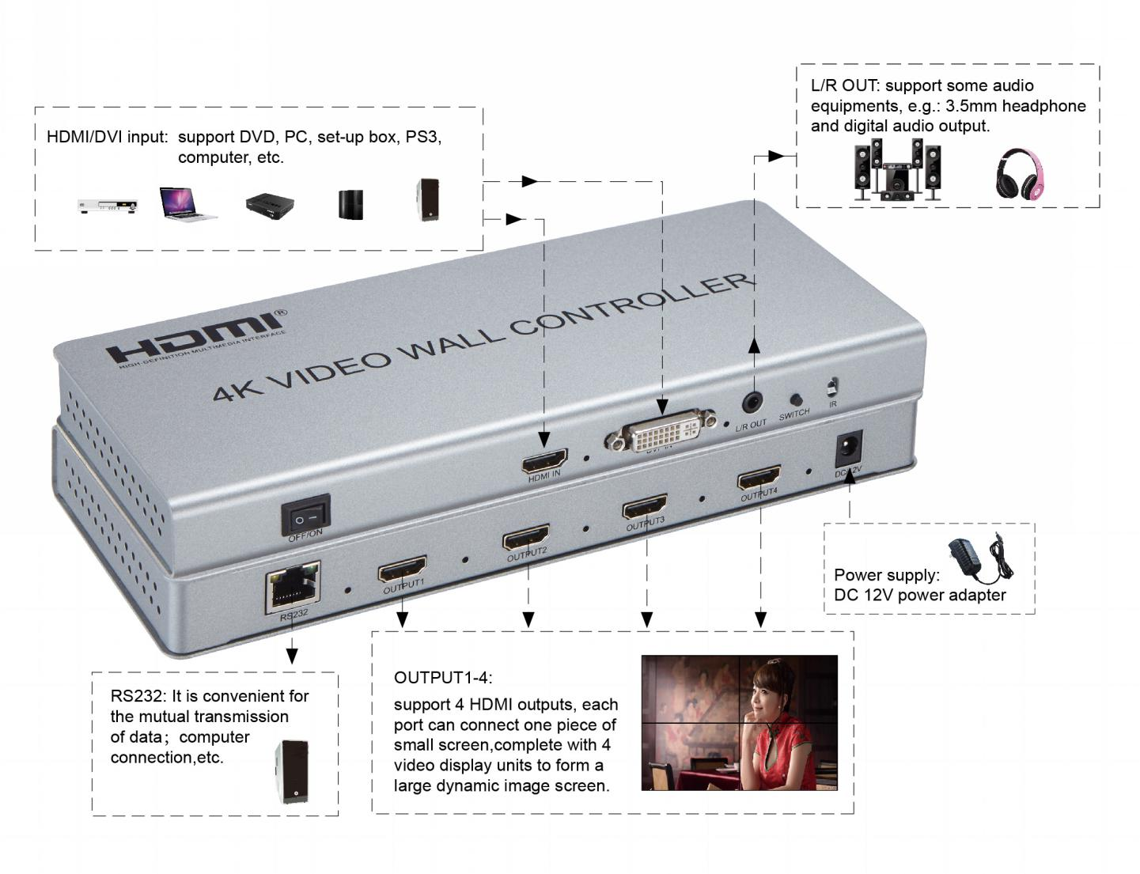
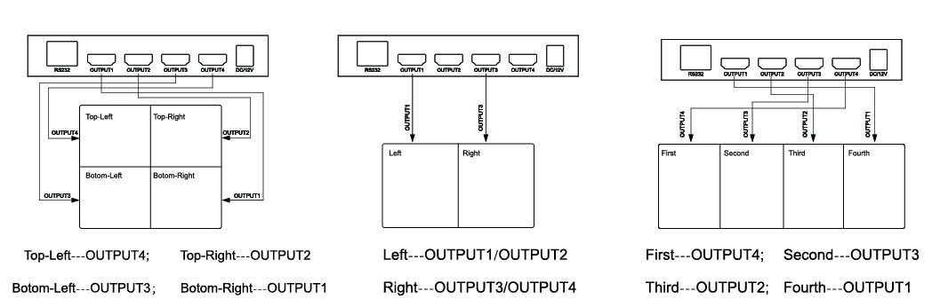

The Package includes:
1. 4K 2X2 video wall controller x1
2. Power adapter x1
3. User Manual x1

